**Project Design Phase-II**

**Data Flow Diagram & User Stories**

|  |  |
| --- | --- |
| Date |  |
| Team ID | LTVIP2025TMID58222 |
| Project Name | House-Hunt: Finding-Your-Perfect-Rental-Home |
| Maximum Marks | 4 Marks |

**Data Flow Diagrams:**

A Data Flow Diagram (DFD) is a traditional visual representation of the information flows within a system. A neat and clear DFD can depict the right amount of the system requirement graphically. It shows how data enters and leaves the system, what changes the information, and where data is stored.

**Example:** [**(Simplified)**](https://developer.ibm.com/patterns/visualize-unstructured-text/)

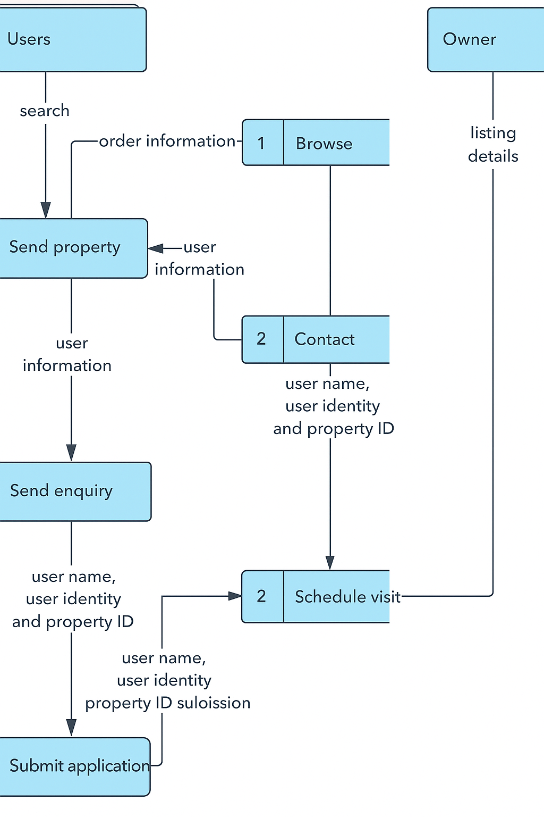

**User Stories**

Use the below template to list all the user stories for the product.

| **User Type** | **Functional Requirement (Epic)** | **User Story Number** | **User Story / Task** | **Acceptance criteria** | **Priority** | **Release** |
| --- | --- | --- | --- | --- | --- | --- |
| Customer (Mobile user) | Registration | USN-1 | As a user, I can register for the application by entering my email, password, and confirming my password. | I can access my account / dashboard | High | Sprint-1 |
| Guest Use | View reviews | USN-2 | As a user, I will receive confirmation email once I have registered for the application | I can receive confirmation email & click confirm | High | Sprint-1 |
| Agent | Chat with renter | USN-3 | As a user, I can register for the application through Facebook | I can register & access the dashboard with Facebook Login | Low | Sprint-2 |
| Support Executive | Review & rate property | USN-4 | As a user, I can register for the application through Gmail | As a customer care agent, I can view and respond to user queries via admin panel. | Medium | Sprint-1 |
| Support Executive | Login | USN-5 | As a user, I can log into the application by entering email & password | I am redirected to the dashboard after successful login. | High | Sprint-1 |
| Owner | Dashboard | USN-6 | As a renter, I can view personalized listings based on my saved preferences. | Listings match my preferred location, budget, and amenities. | High | Sprint-1 |
| Customer (Web user) | Filter & Search | USN-7 | As a renter, I can filter listings by price, location, BHK, and amenities. | Search results update in real time as I change filters. | High | Sprint-1 |
| Customer Care Executive | Property Shortlisting | USN-8 | As a renter, I can save listings to a "Favorites" list. | I can revisit my shortlist from the dashboard. | Medium | Sprint-1 |
| Administrator | Login | USN-9 | As a web user, I can register and log in similarly as mobile users. | Smooth onboarding via web browser. | High | Sprint-1 |
| Customer Care  Exec | Property Upload | USN-10 | As a web user, I can browse available properties and see their details. | Listings are clearly displayed with price, photos, and contact info. | High | Sprint-1 |
| Admin | Dashboard | USN-11 | As an owner, I can manage, edit, or remove my property listings. | My listing appears in search results for renters. | High | Sprint-1 |